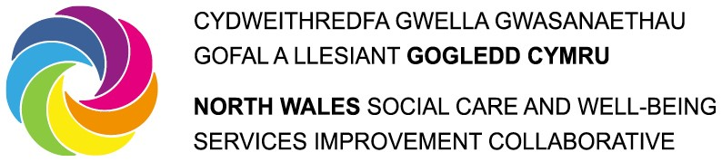

North Wales Regional Partnership Board

INVOLVEMENT DESCRIPTION FOR INDIVIDUAL /SERVICE USER BOARD MEMBERS

APPOINTMENT: Individual /Service User Board Member, North Wales Regional Partnership Board
ACCOUNTABLE TO: North Wales Regional Partnership Board

WORKING WITH: Members of the Regional Partnership Board, local Third Sector Networks, individual and carer groups, statutory partners.

REIMBURSEMENT Currently Voluntary basis with full reimbursement of reasonable expenses

APPOINTMENT TERM Two years

TIME COMMITMENT Approximately 1 day per month

Role of the local North Wales Regional Partnership Board

The North Wales Regional Partnership Board provides leadership in decision making, guidance, influence and support to ensure successful delivery of Health and Care Services to people in North Wales.
Role of the Service User/Individual Partnership Board Member

Membership of the North Wales Regional Partnership Board for service user/individuals provides a voice for people in contact with health and social care services for people of all ages. The members chosen to represent people will be recruited and appointed through completing an expression of interest form. Once the deadline has passed, provided the person specification is completely filled in and meets the general requirements for membership, people will be invited to attend a virtual peer selection meeting to discuss the role and the requirements and choose two people. These people will be encouraged to attend other engagement forums also.

The selection process for individuals participating in the North Wales Regional Partnership Board needs to ensure the 2 representatives selected collectively represent the diversity of those who have experience of or have previously been in contact with health and/or social care services in North Wales.

People will be given the appropriate support to be fully functioning members of the Partnership. Papers will be distributed within enough time to understand and digest the information. Documentation will be clear and accessible, avoiding the use of acronyms or jargon. Information will be circulated to people in ways and in formats most useful to them.

Personal skills
These criteria will be assessed during the application and subsequent peer selection process

CRITERIA | E = Essential D = Desirable | Expression of Interest (EOI)/Recruitment process
Service User/Individuals currently using health and social care services provided by North Wales | E | EOI
Willing to establish strong links with local groups/forums connected with health and social services | E | EOI/  Peer Selection Process
Able to meet a regular time commitment for involvement on the Regional Partnership Board | E | EOI
Ability and skills to promote the perspectives of individuals and to reflect their views. Understanding of “Representation”. | E | EOI/  Peer Selection Process
Ability to work alone or role share and/or as part of a team in partnership | E | EOI
Ability to keep abreast of local and national health and social care legislation, policy and practice | E | EOI/  Peer Selection Process
Good communication skills at all levels and through a variety of mediums | E | EOI/  Peer Selection Process
Ability to be assertive when necessary | E | Peer Selection Process
Ability to be challenging, in a constructive manner | E | Peer Selection Process
Flexible and adaptable | E | EOI  Peer Selection Process
IT skills or willingness to learn | D | EOI
Welsh speaker | D | EOI/  Peer Selection Process

